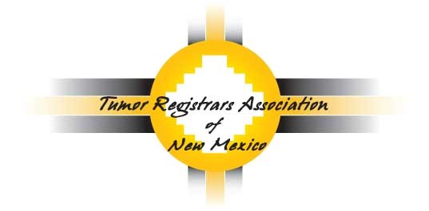

2022 Virtual Southwest Regional Conference
Friday, September 23, 2022
7:45 AM to 4:30 PM

Conference Registration
Name: _____________________________________________________ Title: ______________________
Facility: _________________________________________________________________________________
Address: ____________________________________________________
State: ___________________________________ Zip: ______________
Telephone: ______________________________ Email: ________________________________________

Postmark registration by August 26, 2022 to receive a goody bag from Registry Partners

Member Registration: FREE to Members (Please still fill out the registration form & return)

Non-member Registration: Become a member & attend the conference for FREE (Please Email jsullo@salud.unm.edu for the Membership form)

Please return registration form to: jsullo@salud.unm.edu
OR
Jennifer L. Sullo
5023 Calle de Carino Street NE
Albuquerque, NM 8711

For questions, please contact:
Elizabeth Ramirez-Valdez (President) at: ERamirezValdez@salud.unm.edu
Tanya Dalley (Vice-President) at: TDalley@salud.unm.edu
Jennifer Sullo (Treasurer) at: Jsullo@salud.unm.edu

